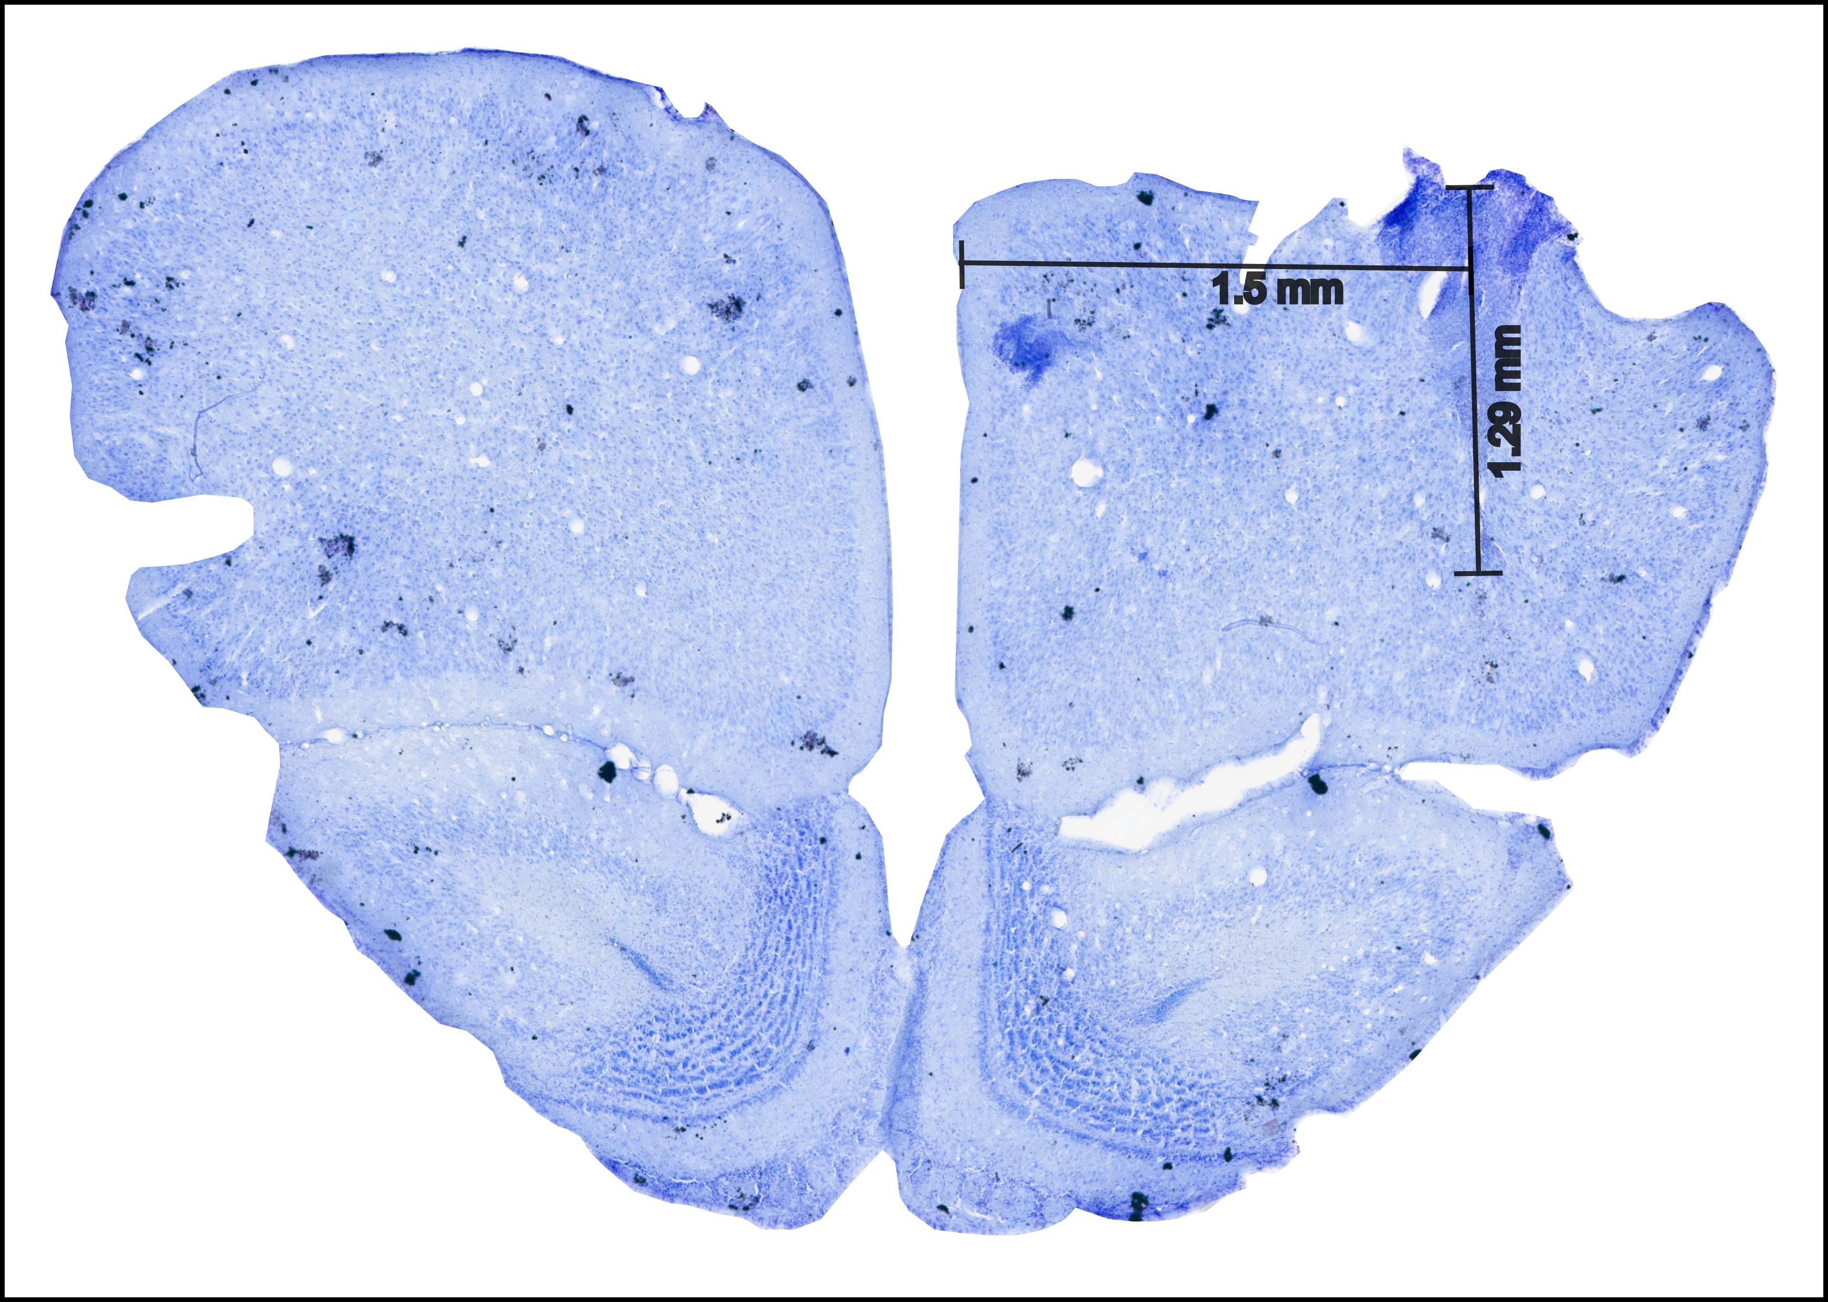

**Figure 1: Sample histology image of the frontal region A (FrA).** The histology slice is taken 4.85 mm anterior to Bregma. The electrode location from the staining can be seen 1.5 mm lateral with a cortical depth of 1.29 mm approximately.

1. **Almost similar travel time after session 5**
2. **Median ± SD pokes before leaving**

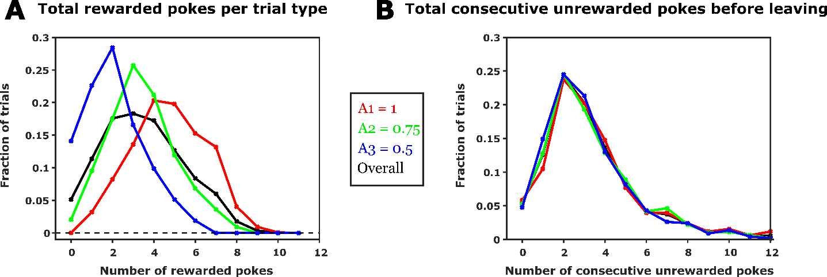

1. **Mean rewarded and unrewarded pokes based on starting probability**

**Figure 2: Behavioural results**

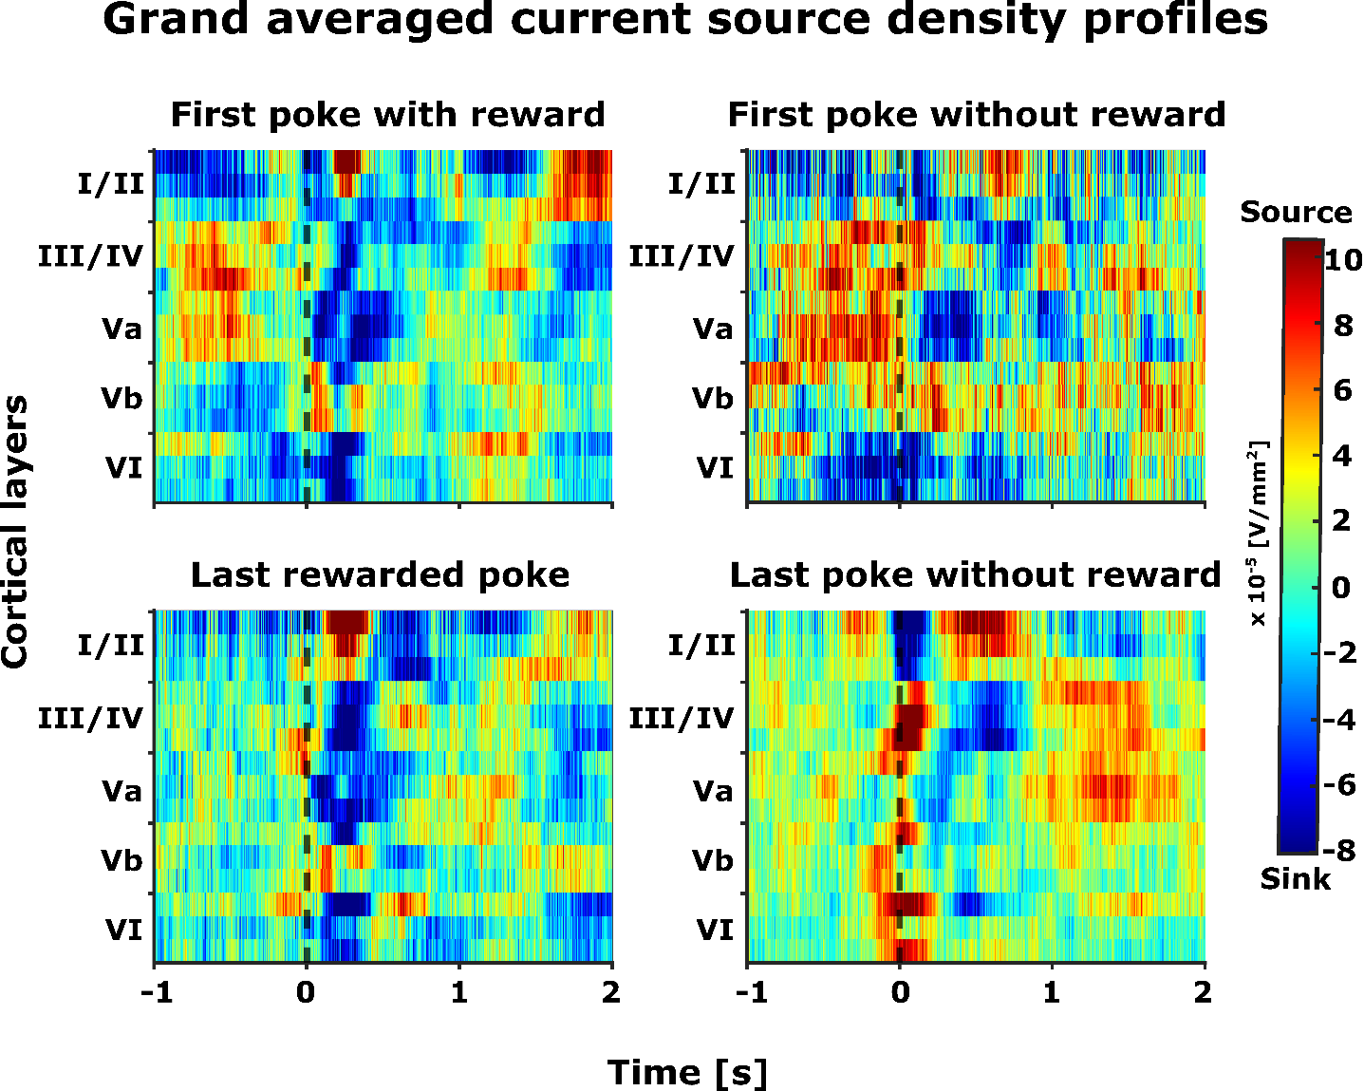

**Figure 3: Grand averaged CSD (n=5)** – The selected epochsrepresent -1 to +2 seconds from the end of the poke (black dashed line, t=0). The selected time interval was taken for four different events (pokes) and its corresponding consequence (reward): (top left) first poke with reward, (top right) first poke without reward, (bottom left) last rewarded poke, and (bottom left) last poke without reward.

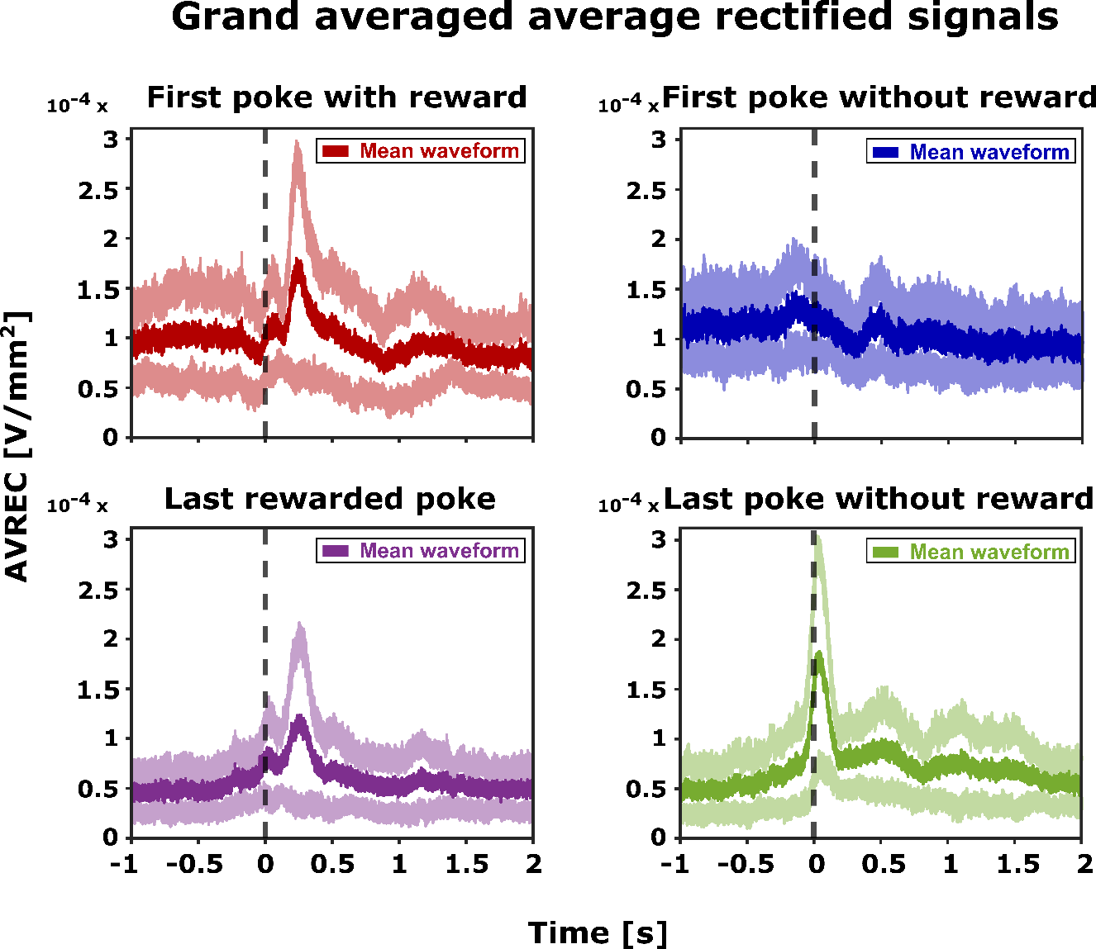

**Figure 4: Grand averaged AVREC (n=5)** – Mean average rectified waveform (dark) along with its standard error (light) is plotted for selected time intervals (epochs). The selected epochsrepresent -1 to +2 seconds from the end of the poke (t=0). AVREC were taken for four different events (pokes) and its corresponding consequence (reward): (top left) first poke with reward, (top right) first poke without reward, (bottom left) last rewarded poke, and (bottom left) last poke without reward.

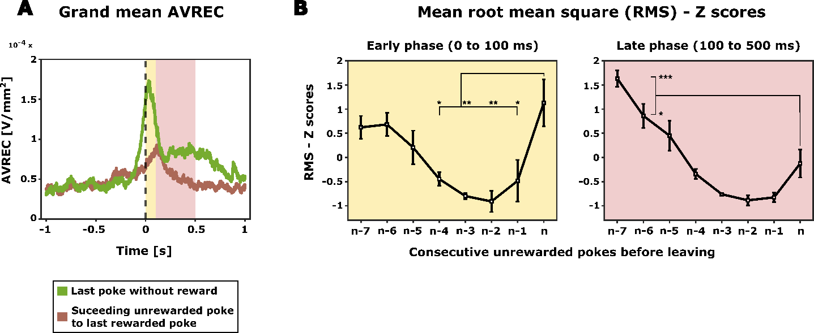

**Figure 5: Mean RMS Z scores** – The average root mean square (RMS) Z score was calculated for unrewarded pokes starting from the last rewarded poke until the last poke (n) before disengaging from the current spout. Using the grand AVREC data (top), three distinct time intervals (epochs) were chosen for RMS computation: before poke phase (-500 to 0 ms), early phase (0 – 100 ms), and late phase (100 – 500 ms).

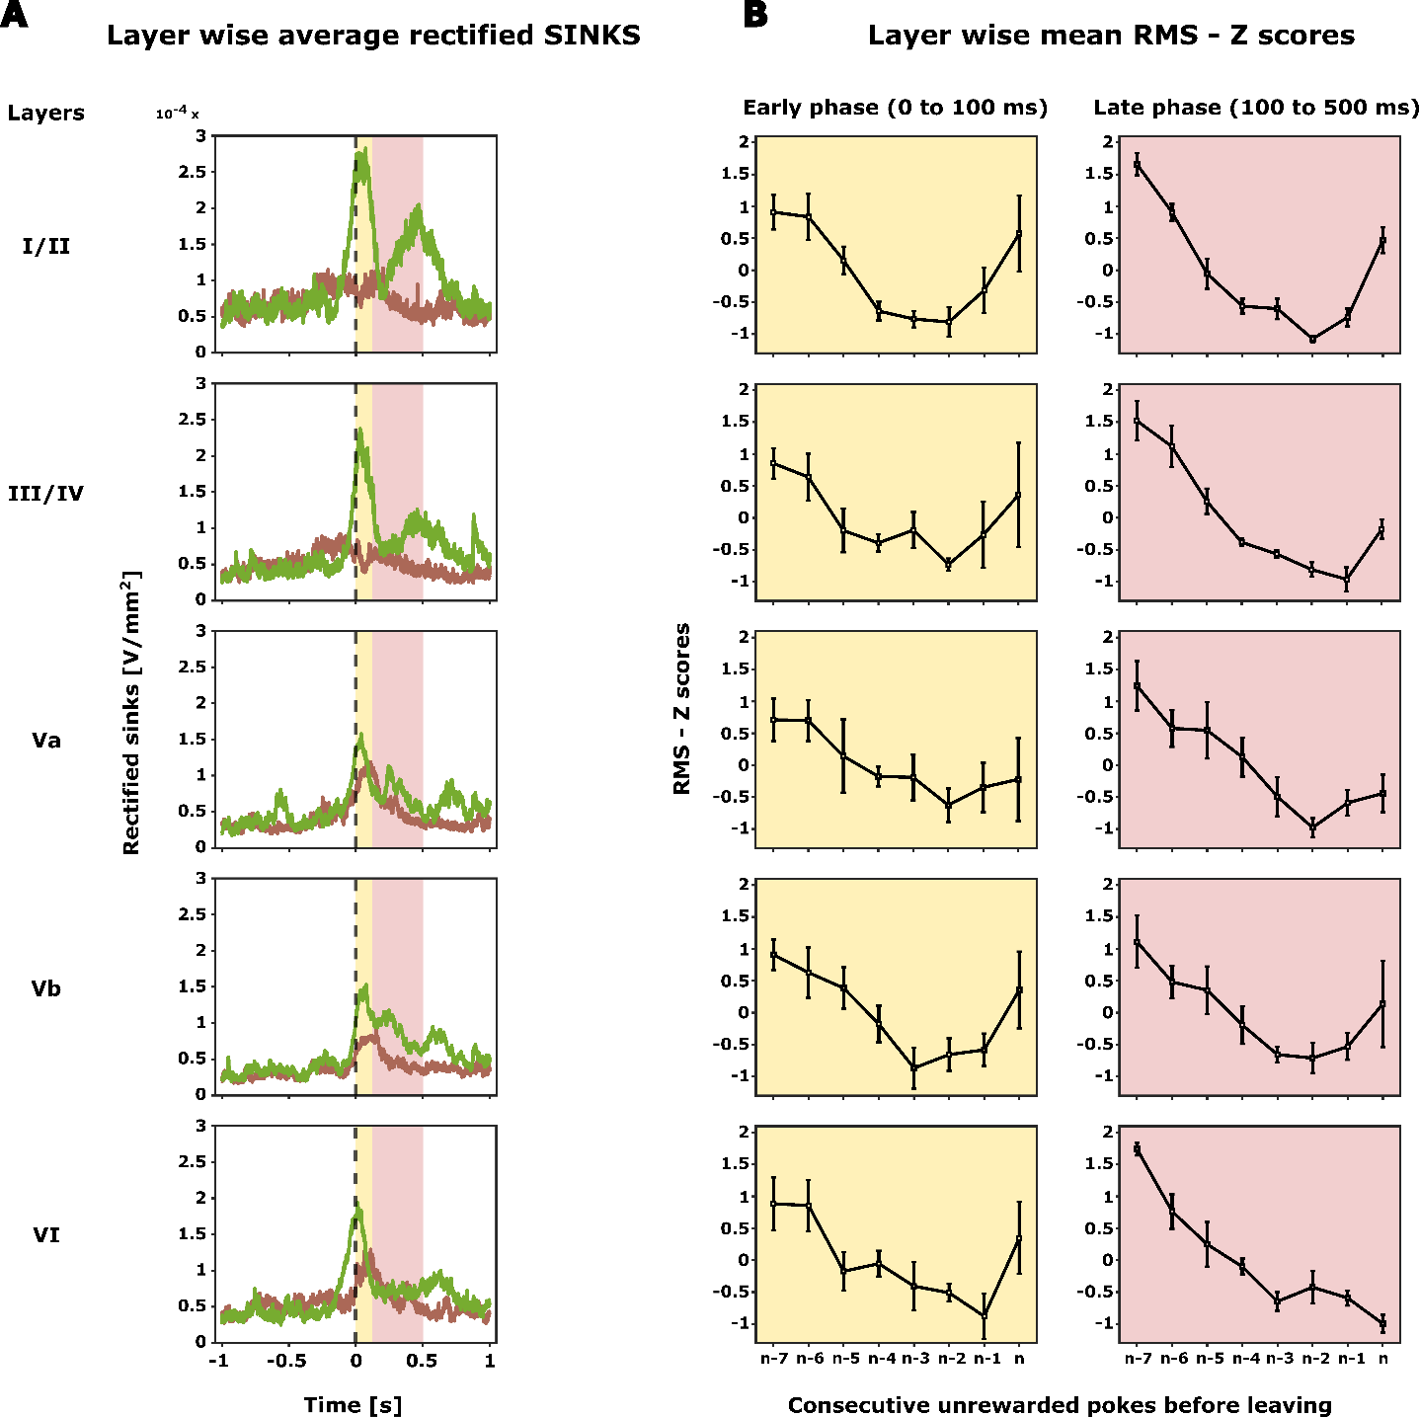

**Figure 6: Layer wise grand averaged rectified sinks (n=5)** – The average rectified sinks was computed for all the identified layers from the grand CSD profile (Figure 3). The selected epochsrepresent -1 to +2 seconds from the end of the poke (t = 0). The selected time interval was taken for last rewarded poke and last poke without reward.

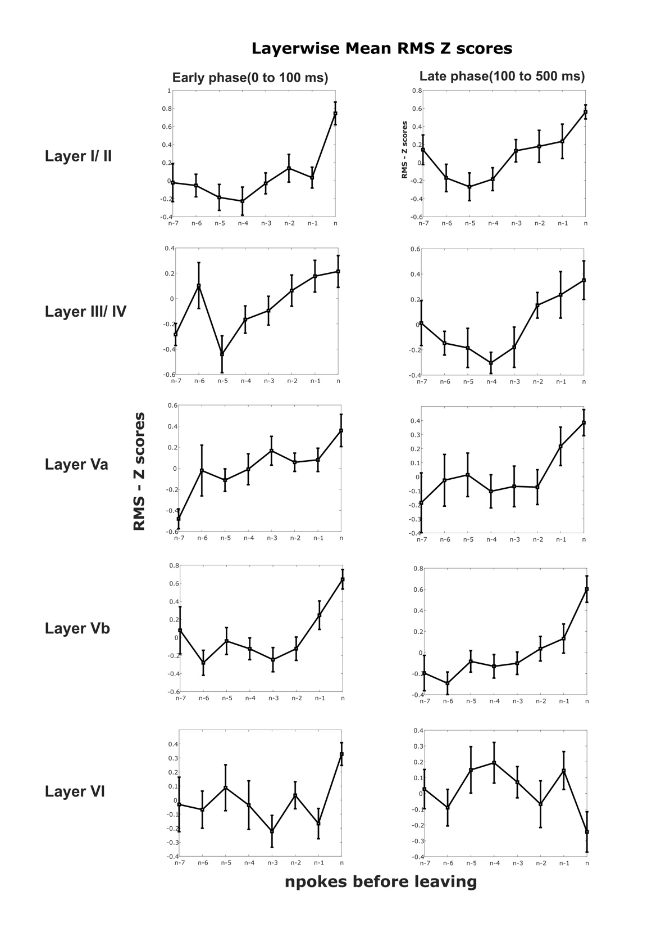

**Figure 7: Layer wise mean RMS – Z scores** – The average root mean square (RMS) Z score was calculated for the average rectified sinks for all the identified layers. The pokes include all the unrewarded pokes starting from the last rewarded poke until the last poke (n) before disengaging from the current spout. Two different epochs were selected from the average rectified sinks (Figure 6) to for the RMS computation: early phase (0 – 100 ms), and late phase (100 – 500 ms).

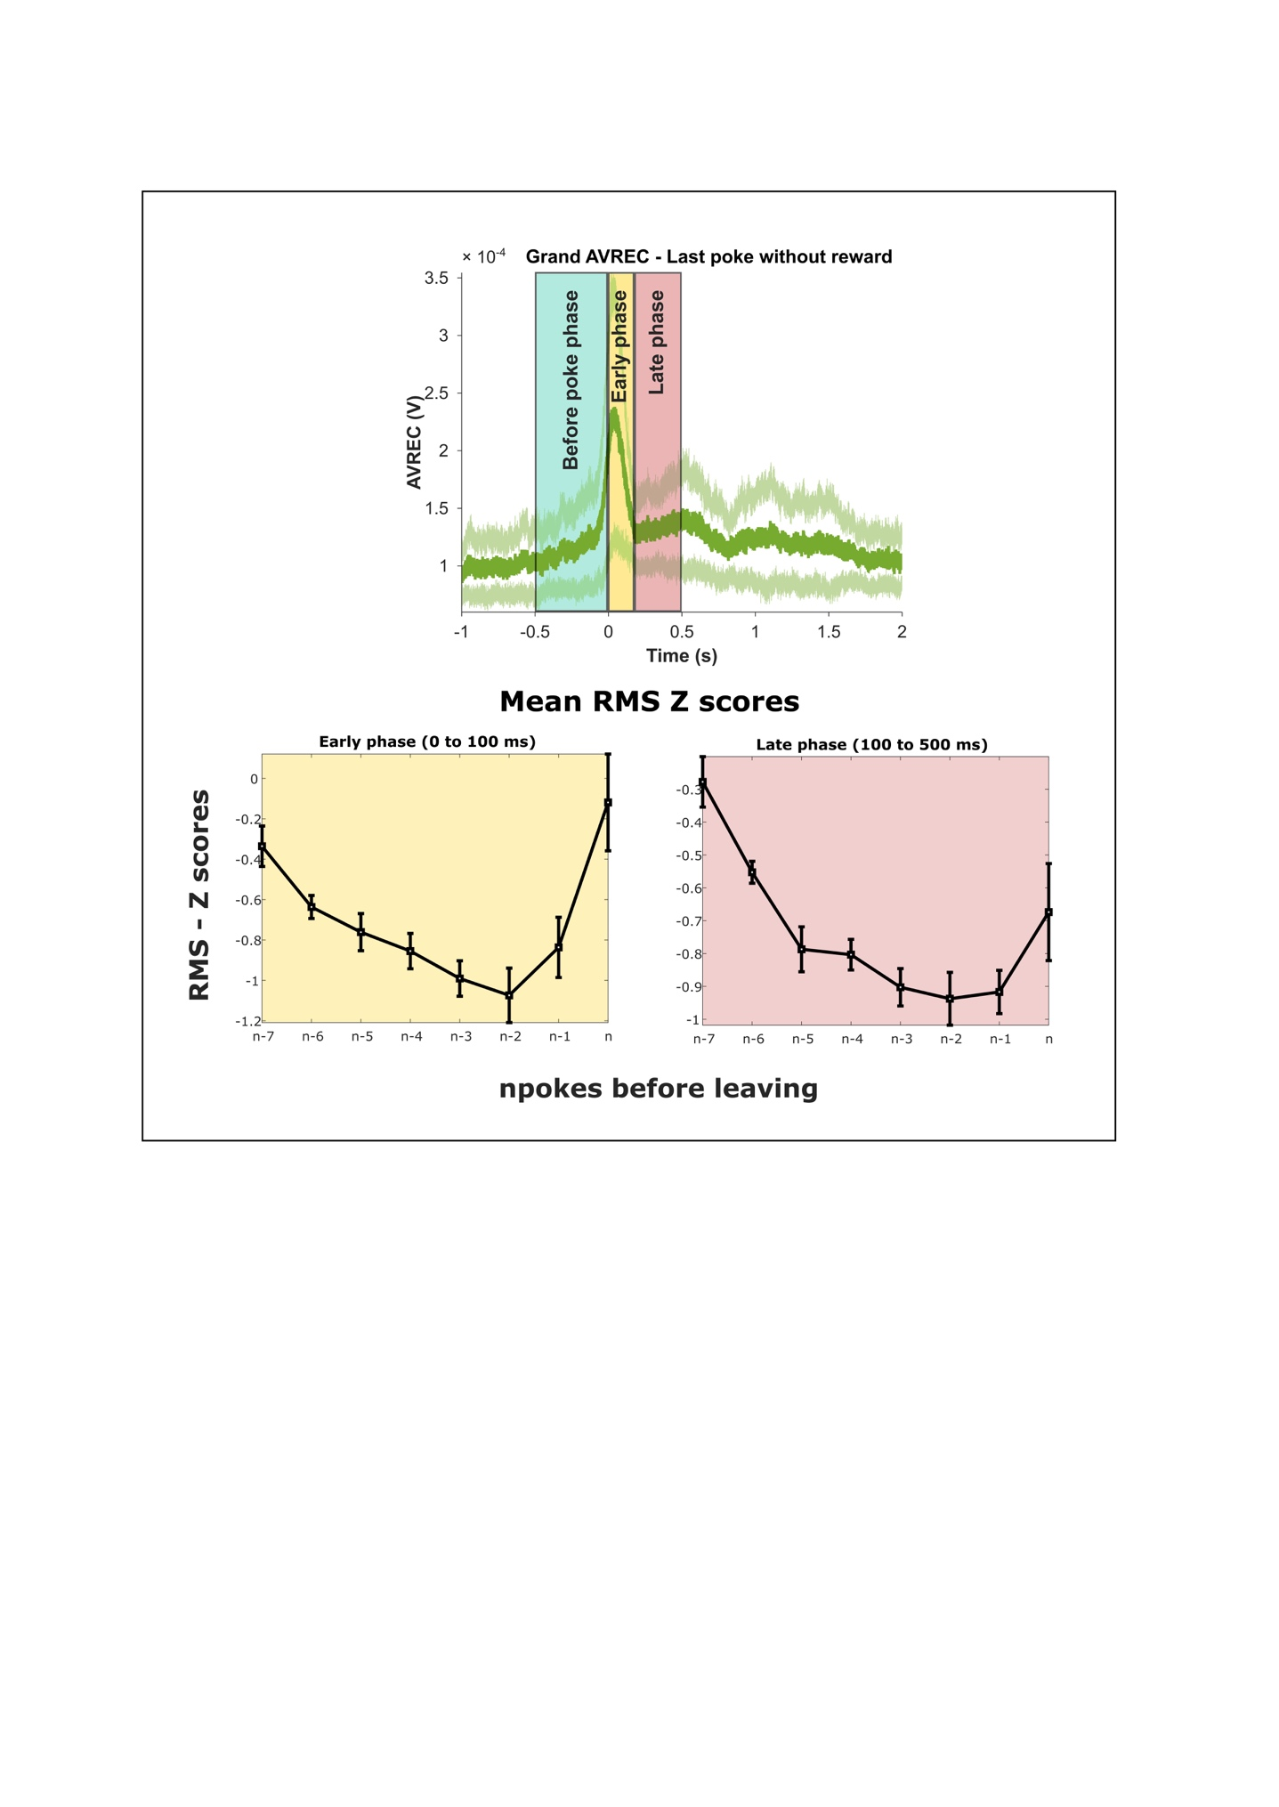

**Figure 8: Mean RMS Z scores** – The average root mean square (RMS) Z score was calculated for unrewarded pokes starting from the last rewarded poke until the last poke (n) before disengaging from the current spout. Using the grand AVREC data (top), three distinct time intervals (epochs) were chosen for RMS computation: before poke phase (-500 to 0 ms), early phase (0 – 100 ms), and late phase (100 – 500 ms).

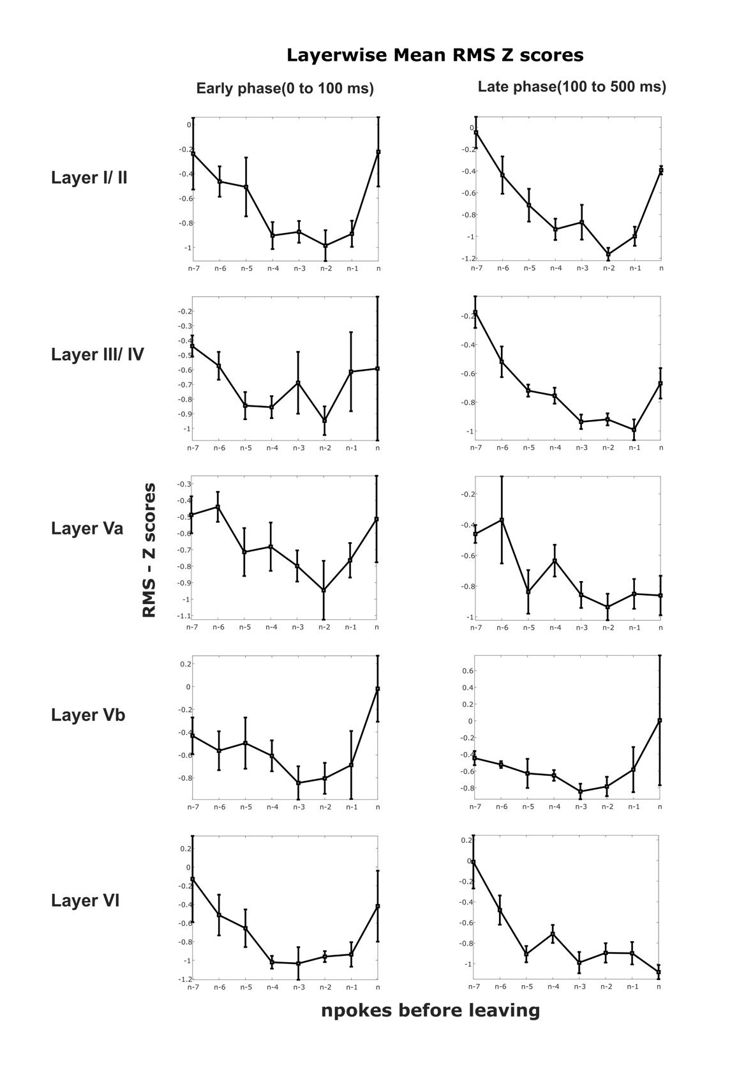

**Figure 9: Layer wise mean RMS – Z scores** – The average root mean square (RMS) Z score was calculated for the average rectified sinks for all the identified layers. The pokes include all the unrewarded pokes starting from the last rewarded poke until the last poke (n) before disengaging from the current spout. Two different epochs were selected from the average rectified sinks (Figure 6) to for the RMS computation: early phase (0 – 100 ms), and late phase (100 – 500 ms).